Benha university

Faculty of engineering at shoubra

Preparatory year

Name : Mohamed emad Mansour monshar

E_mail : Muhammad 20843@feng.bu.edu.eg

Code : 2166120200100843

Group : 6

Sec : 35

B.N : 8

# Topic : Artificial Intelligence

Github link :

Screenshots : main page website

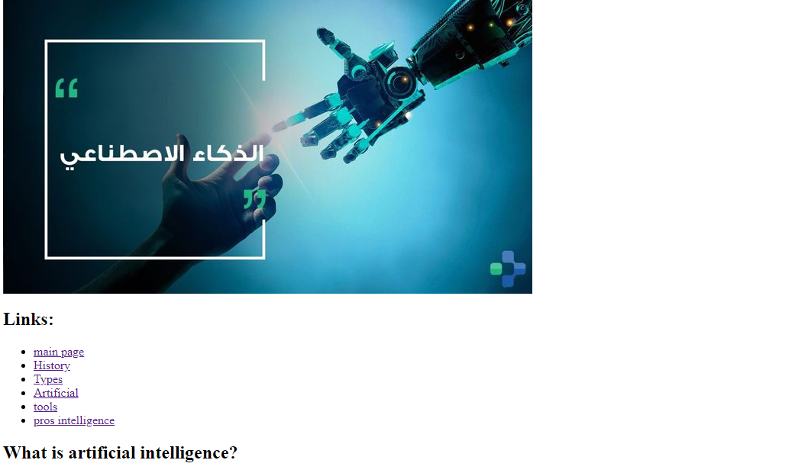

Screenshots : main page code:

